ASSIGNMENT 2(AI ML)

1)In logistic regression, what is the logistic function (sigmoid function) and how is it used to compute probabilities?

A) In logistic regression, the logistic function, also known as the sigmoid function, plays a crucial role in converting the output of a linear combination of features and coefficients into a probability value. This process is essential because logistic regression is primarily used for binary classification tasks, where the goal is to predict the probability of an observation belonging to a particular class.

The logistic function is represented mathematically as

σ(z)= 1/(1+e-z)

where:

* Z is the input to the function, which is the linear combination of features and coefficients. It's calculated as z==β0 +β1x1 +β2x2 +…+βn xn, are the feature values.
* e is the base of the natural logarithm, approximately equal to 2.71828.

Now, let's break down how the logistic function works and why it's suitable for computing probabilities in logistic regression:

1. Range of Output: The logistic function outputs values between 0 and 1. This is crucial for logistic regression because it allows us to interpret the output as a probability. Specifically, the output represents the probability of the observation belonging to the positive class (usually labeled as 1 in binary classification) versus the probability of belonging to the negative class (usually labeled as 0).
2. S-Shaped Curve: The logistic function produces an S-shaped curve. This shape is characteristic of sigmoid functions and is desirable in logistic regression because it smoothly transitions from 0 to 1. As the input z increases, the output of the logistic function approaches 1, indicating a higher probability of belonging to the positive class. Conversely, as the input z decreases, the output approaches 0, indicating a higher probability of belonging to the negative class.
3. Monotonicity: The logistic function is monotonic, meaning it consistently increases or decreases without any abrupt changes in direction. This property is beneficial for logistic regression because it ensures that changes in the input features result in predictable changes in the predicted probabilities.
4. Differentiability: The logistic function is differentiable, which is necessary for training logistic regression models using optimization algorithms like gradient descent. The smoothness of the logistic function enables efficient optimization of the model parameters (coefficients) to minimize the difference between predicted probabilities and actual class labels.

In summary, the logistic function transforms the output of the linear regression model into probabilities by mapping it onto a bounded interval between 0 and 1. This transformation allows logistic regression to predict the likelihood of an observation belonging to a particular class, making it a powerful tool for binary classification tasks.

2)When constructing a decision tree, what criterion is commonly used to split nodes ,and how is it calculated.

A) The commonly used criterion for splitting nodes in a decision tree is called impurity or purity measure. The two most common impurity measures are Gini impurity and entropy (information gain).

1. Gini Impurity: Gini impurity measures the probability of incorrectly classifying a randomly chosen element if it was randomly labeled according to the distribution of labels in the node. It is calculated as follows:

Gini impurity=1−∑ik=1 pi2

where k is the number of classes, and Pi is the probability of randomly choosing an element of class i in the node.

2.Entropy (Information Gain): Entropy measures the amount of uncertainty or randomness in the data. It is calculated using the formula:

Entropy=−∑k i=1 pi  log2(pi)

where k is the number of classes, and pi  is the probability of randomly choosing an element of class i in the node.

The splitting criterion in decision trees is chosen based on minimizing impurity or maximizing information gain. The attribute that results in the greatest reduction in impurity (or the highest information gain) is selected as the splitting attribute for the node.

1’Calculate the impurity (Gini impurity or entropy) for the current node.

For each candidate split.

2. calculate the impurity of the child nodes that would result from splitting on that attribute.

3.Calculate the impurity (or information gain) of the split by combining the impurities of the child nodes, weighted by the proportion of samples in each child node.

The attribute with the highest reduction in impurity (or the highest information gain) is chosen as the splitting attribute for the node. This process is recursively applied to each child node until a stopping criterion is met, such as reaching a maximum depth, having nodes with a minimum number of samples, or achieving perfect purity.

3)Explain the concept of entropy and information gain in the context of decision tree construction.

A) Entropy:

* Entropy measures the impurity or disorder of a dataset before splitting.

Mathematically, entropy for a set S with m classes is calculated as:

Entropy( S)=−∑mi=1pilog2(pi) where pi is the probability of class i in set S.

Entropy is maximum when all classes are equally distributed, indicating maximum disorder.

2.Information Gain:

* Information gain is the measure of the effectiveness of a particular attribute in classifying the dataset.
* It quantifies the reduction in entropy achieved after splitting the dataset based on that attribute.
* Mathematically, information gain for an attribute A on set S is calculated as:

Gain(S,A)=Entropy(S)−∑ v ∈values(A)(|S∣ / ∣S v∣)×Entropy(S v) where:

* values(A) is the set of possible values of attribute A.
* ∣S∣ is the number of instances in set S.
* ∣S v∣ is the number of instances in set S with value v for attribute A.
* Entropy(S v ) is the entropy of the subset S V after splitting on attribute A with value v.
* Higher information gain indicates that splitting the dataset based on that attribute will lead to more homogeneous subsets in terms of the target variable

3.Decision Tree Construction:

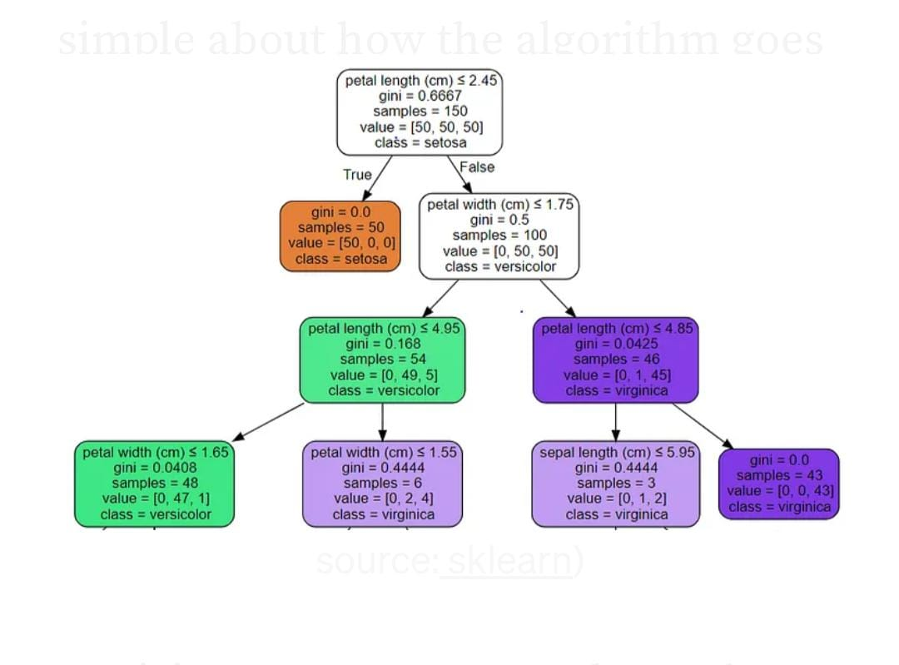

* To construct a decision tree, the algorithm iterates over all attributes and calculates the information gain for each.
* The attribute with the highest information gain is chosen as the splitting criterion for the current node.
* This process is repeated recursively for each subset (branch) until a stopping criterion is met, such as reaching a maximum depth, having only instances of the same class, or reaching a minimum number of instances in a node.

By selecting attributes with the highest information gain at each step, decision trees aim to create splits that maximize the homogeneity of the subsets, leading to a more accurate classification of instances.

4.How does the random forest algorithm utilize bagging and feature randomization to improve classification accuracy.

A) Random forest is a machine learning algorithm that operates by constructing a multitude of decision trees during training and outputs the class that is the mode of the classes (classification) or mean prediction (regression) of the individual trees. Bagging, which stands for Bootstrap Aggregating, is a technique used in ensemble learning where multiple models are trained independently on different subsets of the training data, and their predictions are combined to produce the final output.

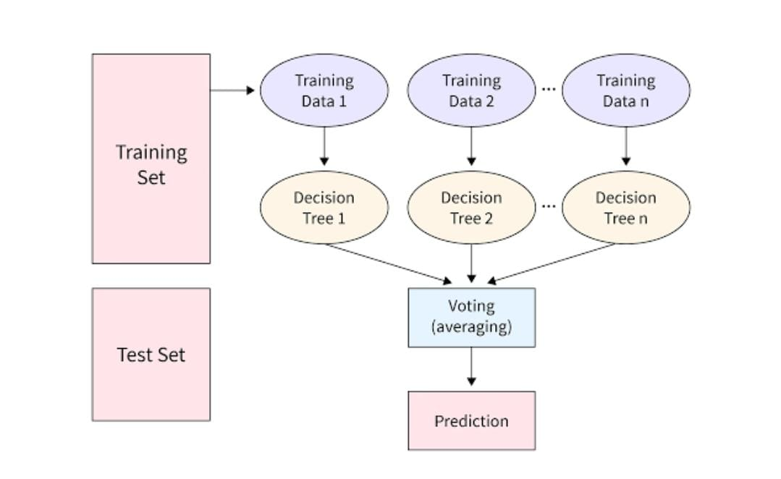

Here's how random forest utilizes bagging to improve classification accuracy:

Bootstrap Sampling: In bagging, each decision tree in the random forest is trained on a different bootstrap sample of the original training data. Bootstrap sampling involves randomly selecting subsets of the training data with replacement. This means that some instances may be selected multiple times for training, while others may not be selected at all.

Random Feature Selection: At each node of the decision tree, instead of considering all features for splitting, random forest only considers a subset of features. This further diversifies the trees in the forest and reduces the correlation among them.

Voting: Once all the decision trees are trained, for classification tasks, each tree "votes" for a class. The class with the most votes across all trees is then assigned as the final prediction. This voting mechanism helps in improving the accuracy and generalization of the model by reducing overfitting.

Out-of-Bag (OOB) Error Estimation: Since each decision tree is trained on a different subset of the data, there will be some instances that are not included in the bootstrap sample for training a particular tree. These instances are called out-of-bag samples. The performance of the random forest can be estimated using these out-of-bag samples, which provides a built-in validation mechanism without the need for a separate validation set.

5)What distance metric is typically used in k- nearest neighbors (KNN) classification and how does it impact the algorithms performance.

A) The most commonly used distance metrics in k-nearest neighbor (KNN) classification are:

Euclidean distance: This is the straight-line distance between two points in a Euclidean space. It is calculated as the square root of the sum of the squared differences between corresponding coordinates of two points.

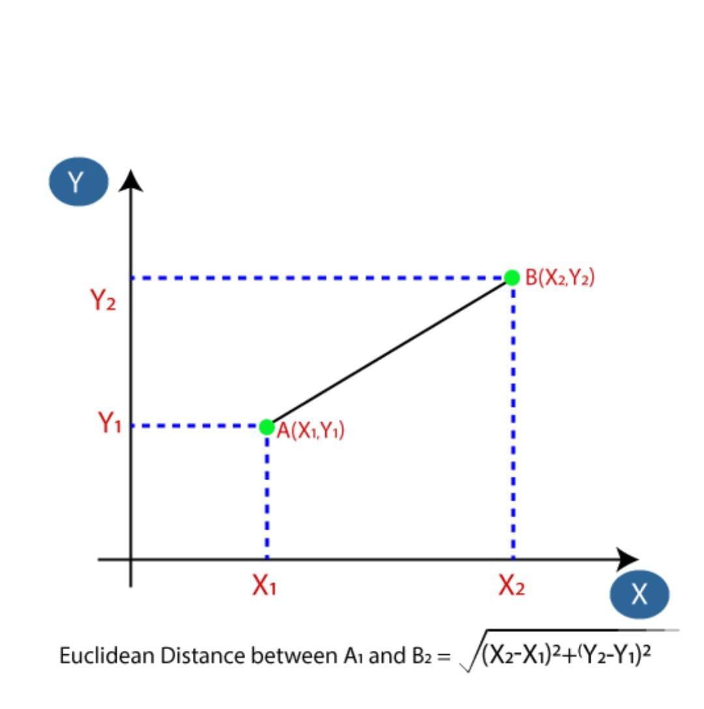

Manhattan distance (or Taxicab distance): This is the sum of the absolute differences between the coordinates of two points. It represents the distance a taxicab would travel in a city if it could only move along orthogonal city blocks.

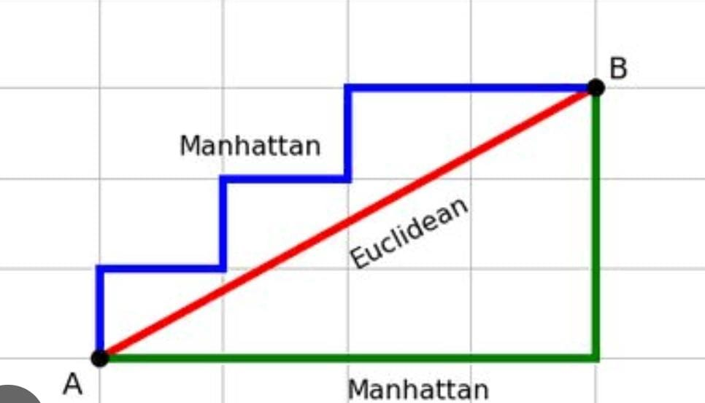

Minkowski distance: This is a generalization of both Euclidean and Manhattan distances, where the distance between two points is calculated using a parameter p that defines the order of the Minkowski distance. When p=1, it reduces to Manhattan distance, and when p=2,it reduces to Euclidean distance.

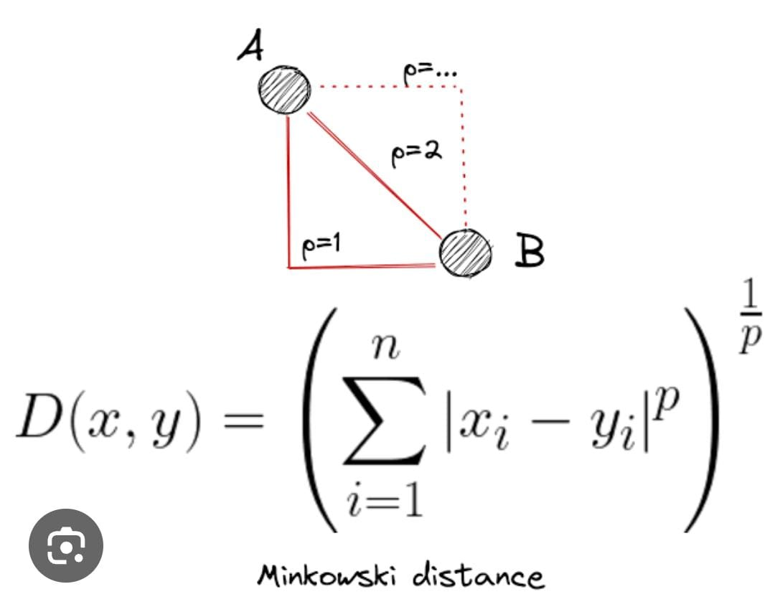

6) Describe the native bayes assumption of features independence and its implications for classification.

A) The Naive Bayes assumption of feature independence is a fundamental aspect of the Naive Bayes classifier. It assumes that the presence of a particular feature in a class is unrelated to the presence of any other feature. Mathematically, this is represented as

P(xi |C, xi ,x2 ,….,xi-1,xi+1,….,xn )=P(xi |C)

Where x1 represents the i-th feature ,C represents all other features except xi .

Implications for classification:

Simplification of the Probability Calculation: By assuming feature independence, the joint probability of all features given a class can be expressed as the product of the individual probabilities of each feature given the class

P(x1,x2, ….,xn |C)=P(x1|C)\*P(x2|C)\*…\*P(xn |C)

This simplifies the calculation of probabilities, making the Naive Bayes classifier computationally efficient, especially for high-dimensional datasets.

1.Limited Expressiveness: While the assumption of feature independence simplifies calculations, it can be overly simplistic and may not accurately reflect real-world data. In many cases, features are correlated or dependent on each other, violating the independence assumption. Despite this limitation, Naive Bayes classifiers often perform surprisingly well in practice, especially when the independence assumption approximately holds or when the classes are well-separated.

This simplifies the calculation of probabilities, making the Naive Bayes classifier computationally efficient, especially for high-dimensional datasets.

2.Robustness to Irrelevant Features: Naive Bayes classifiers tend to be robust to irrelevant features because the presence or absence of irrelevant features will have little effect on the conditional probabilities of the relevant features. This property can be advantageous when dealing with noisy or incomplete data.

3.Impact of Dependent Features: If there are dependencies among features, the Naive Bayes classifier may produce suboptimal results. In such cases, techniques like feature engineering or using more sophisticated classifiers that can capture dependencies among features (e.g., Bayesian networks, tree-based models) may be more appropriate.

In summary, while the assumption of feature independence simplifies the Naive Bayes classifier and makes it computationally efficient, it may not always hold in real-world scenarios. Understanding the implications of this assumption is crucial for effectively applying and interpreting Naive Bayes classifiers in practice.

7) In SVMS, what is the role of the kernel function , and what are some commonly used Kernel function?

A) In Support Vector Machines (SVM), the kernel function plays a crucial role in transforming the input data into a higher-dimensional space where it can be more easily separated by a hyperplane. The kernel function essentially computes the inner product between two points in this higher-dimensional space without explicitly computing the transformation itself. This is beneficial because it allows SVMs to efficiently handle high-dimensional data without explicitly calculating the transformed feature vectors.

Here's a detailed explanation of the role of the kernel function and some commonly used kernel functions:

1.Role of Kernel Function:

* Transformation: The kernel function implicitly maps the input data from the original feature space to a higher-dimensional space.
* Inner Product Computation: Instead of computing the transformed feature vectors explicitly, the kernel function computes the inner product between points in the higher-dimensional space directly.
* Decision Boundary: In the transformed space, finding a hyperplane that separates the data into different classes becomes equivalent to finding a hyperplane in the original space, but with better separation capabilities.

2.Commonly Used Kernel functions:

a. Linear Kernal:

-Function :K(x ,x’)=xT x’

-Explanation : This is the simplest kernel function. It computes the inner product of the input feature vectors in the original space.

b. Polynomial Kernel:

-Function :K(x ,x’)=(xT x’+ c)d

Explanation: This kernel function applies polynomial transformations to the original feature space. The degree 'd' and the constant term 'c' are parameters that can be adjusted.

c. Gaussian Radial Basis Function (RBF) Kernel:

-Function :K(x, x’) = tanh(αxT x’+ c)

Explanation: This kernel function is based on the hyperbolic tangent function. It can be useful when dealing with non-linearly separable data.

e. Custom Kernels:

- Explanation: In addition to these standard kernels, custom kernels can be defined based on the specific problem domain. These could involve domain-specific transformations or similarity measures.

Each of these kernel functions has its own characteristics and is suitable for different types of data distributions. The choice of kernel function often depends on the problem at hand and requires experimentation to determine which kernel yields the best performance.

8) Discuss the bias-variance tradeoff in the context of model complexity and over fitting.

A) The bias-variance tradeoff refers to the balance between bias and variance in the performance of a machine learning model.

* Bias: Bias refers to the error introduced by approximating a real-world problem with a simplified model. High bias means the model is too simple to capture the underlying structure of the data, leading to underfitting.
* Variance: Variance refers to the model's sensitivity to fluctuations in the training data. High variance means the model is too complex and captures noise in the training data, leading to overfitting.

As model complexity increases, bias decreases but variance increases. Conversely, as model complexity decreases, bias increases but variance decreases. The goal is to find the right balance between bias and variance that minimizes the overall error, typically achieved through techniques like cross-validation, regularization, and choosing an appropriate model complexity.

Overfitting occurs when a model learns the training data too well, capturing noise and outliers, leading to poor generalization on unseen data. It often happens with overly complex models, where the model fits the training data too closely. Regularization techniques can help mitigate overfitting by penalizing overly complex models.

In summary, the bias-variance tradeoff highlights the delicate balance between model simplicity and complexity, where finding the optimal point helps in achieving better generalization performance on unseen data.

9.How does Tensor Flow facilitate the creation and training of neural network?

A) TensorFlow is an open-source machine learning library developed by Google that facilitates the creation and training of neural networks. Here's a detailed explanation of how TensorFlow achieves this:

Computation Graphs: TensorFlow represents computations as a directed graph called the computation graph. In this graph, nodes represent mathematical operations, and edges represent the flow of tensors (multi-dimensional arrays) between operations. This graph allows TensorFlow to efficiently execute computations on CPUs, GPUs, or even distributed computing environments.

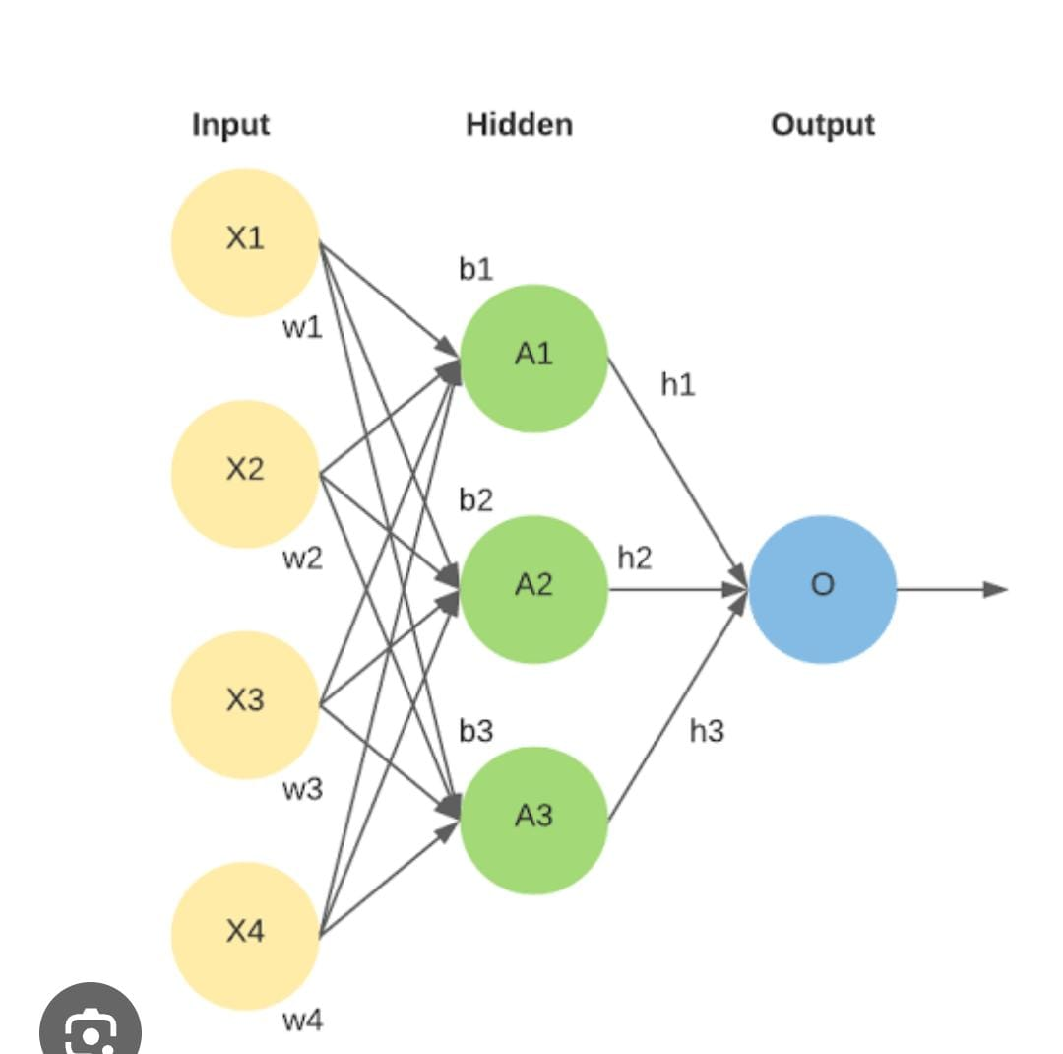

Tensors: Tensors are the primary data structure in TensorFlow. They represent multi-dimensional arrays, which are fundamental to neural network operations. TensorFlow provides a rich set of functions to create, manipulate, and transform tensors, making it easy to handle data for neural network operations.

Automatic Differentiation: TensorFlow provides automatic differentiation capabilities through its tf .Gradient Tape API. This allows users to compute gradients of any differentiable function with respect to its parameters. Automatic differentiation is crucial for training neural networks using gradient-based optimization algorithms such as stochastic gradient descent (SGD).

Modularity and Flexibility: TensorFlow offers a high degree of modularity, allowing users to build complex neural network architectures by combining simple building blocks called layers. TensorFlow provides a comprehensive collection of pre-built layers for common tasks such as convolution, recurrent, and dense layers. Additionally, users can define custom layers to implement novel architectures or functionality.

Optimization Algorithms: TensorFlow includes a variety of optimization algorithms for training neural networks, including SGD, Adam, RMSProp, and Adagrad . These algorithms are implemented efficiently and can be easily customized or extended to suit specific requirements.

GPU Acceleration: TensorFlow seamlessly integrates with GPUs to accelerate computation, making it possible to train large neural networks much faster than on CPUs alone. TensorFlow automatically manages the distribution of computations across available GPU devices, allowing users to take advantage of parallelism and significantly reduce training times.

High-Level APIs: TensorFlow provides high-level APIs such as Keras, which simplify the process of building and training neural networks. Keras offers a user-friendly interface for defining models, specifying loss functions, and configuring optimization strategies. This abstraction layer hides the complexities of TensorFlow's lower-level operations, making it accessible to users with varying levels of expertise.

Tensor Board: TensorFlow includes Tensor Board, a visualization toolkit that allows users to visualize and monitor various aspects of their models during training. Tensor Board can display training curves, model architectures, histograms of weights and biases, and other useful information, helping users analyze and debug their neural networks effectively.

By combining these features, TensorFlow provides a powerful and flexible platform for creating, training, and deploying neural networks across a wide range of applications and domains. Its rich ecosystem, active community, and support for both research and production make it one of the most popular tools for machine learning and deep learning tasks

10.Explain the concept of cross-validation and its importance in evaluating model performance.

A)C ross-validation is a technique used in machine learning to assess how well a model will generalize to new, unseen data. The process involves splitting the dataset into multiple subsets, known as folds. The model is trained on a portion of the data (training set) and then validated on a different portion (validation set). This process is repeated multiple times, each time with a different partitioning of the data. The performance metrics from each iteration are then averaged to provide an overall estimation of the model's performance.

There are several types of cross-validation techniques, with the most common being k-fold cross-validation. In k-fold cross-validation, the dataset is divided into k equal-sized folds. The model is trained on k-1 folds and validated on the remaining fold. This process is repeated k times, each time using a different fold as the validation set.

The importance of cross-validation lies in its ability to provide a more accurate estimate of a model's performance compared to simply using a single train-test split. By training the model on multiple subsets of the data and averaging the results, cross-validation reduces the risk of overfitting to any particular subset of the data. It also provides a better understanding of how the model performs across different subsets of the data, which can help identify potential issues such as bias or variance.

Additionally, cross-validation helps in hyperparameter tuning. By evaluating the model's performance on different subsets of the data, it becomes easier to identify the optimal hyperparameters that result in the best overall performance.

Overall, cross-validation is a crucial tool in evaluating model performance as it provides a more reliable estimate of a model's ability to generalize to new, unseen data and aids in the selection of optimal hyperparameters.

11. What techniques can be employed to handle over fitting in machine learning models?

A) Overfitting occurs when a machine learning model learns the training data too well, including noise and irrelevant patterns, which leads to poor performance on unseen data. To mitigate overfitting, several techniques can be employed

Cross-validation: Utilize techniques like k-fold cross-validation to assess model performance on different subsets of the data. This helps in estimating how the model will perform on unseen data.

Train with more data: Increasing the size of the training dataset can help the model generalize better by exposing it to more diverse examples.

Feature selection: Selecting only the most relevant features can reduce overfitting by focusing the model on the most informative aspects of the data.

Regularization: Techniques like L1 (Lasso) and L2 (Ridge) regularization add penalty terms to the loss function, discouraging overly complex models by penalizing large coefficients.

Early stopping: Monitor the model's performance on a validation set during training and stop training when performance starts to degrade. This prevents the model from over-optimizing on the training data.

Ensemble methods: Combine multiple models (e.g., bagging, boosting, stacking) to reduce overfitting. By averaging predictions from multiple models, ensemble methods often generalize better than individual models.

Dropout: In neural networks, dropout randomly removes a fraction of neurons during training, forcing the network to learn more robust features and reducing overfitting.

Data augmentation: Increase the size and diversity of the training data by applying transformations such as rotation, translation, and flipping. This helps the model generalize better to unseen variations of the data.

Simplifying the model architecture: Reduce the complexity of the model by decreasing the number of layers, nodes, or parameters. A simpler model is less likely to overfit, especially when the dataset is small or noisy.

Bayesian methods: Bayesian techniques incorporate prior knowledge about the parameters into the model training process, resulting in more stable estimates and reduced overfitting, especially when data is limited.

By employing a combination of these techniques, practitioners can effectively mitigate overfitting and build more robust machine learning models that generalize well to unseen data.

12.What is the purpose of regularization in machine learning and how does it work?

A) Regularization in machine learning is a technique used to prevent overfitting, which occurs when a model learns to perform well on the training data but fails to generalize to new, unseen data. Regularization works by adding a penalty term to the model's cost function, encouraging it to learn simpler patterns that are more likely to generalize well.

There are several types of regularization techniques, but two of the most common are L1 regularization (Lasso) and L2 regularization (Ridge). Let's delve into each

L1 Regularization (Lasso):

In L1 regularization, the penalty term is the absolute value of the coefficients of the model multiplied by a constant, typically denoted as lambda (λ).

Mathematically, the cost function with L1 regularization is the sum of the original loss function (such as mean squared error for regression or cross-entropy for classification) and the product of lambda and the sum of absolute values of the model's coefficients.

L1 regularization encourages sparsity in the model, meaning it tends to force the coefficients of less important features to be exactly zero. This can be useful for feature selection, as it effectively removes irrelevant features from the model.

L2 Regularization (Ridge):

In L2 regularization, the penalty term is the squared magnitude of the coefficients of the model multiplied by λ.

Mathematically, the cost function with L2 regularization is the sum of the original loss function and the product of λ and the sum of squared values of the model's coefficients.

L2 regularization penalizes large coefficients more heavily than small ones, leading to a more even distribution of importance among all features. It helps to prevent extreme values of the coefficients, thus reducing model complexity .The choice between L1 and L2 regularization depends on the specific problem and the desired characteristics of the model. L1 regularization tends to produce sparse models with a smaller number of non-zero coefficients, while L2 regularization generally results in smoother models with all coefficients being small but non-zero.

In summary, regularization is crucial in machine learning to prevent overfitting by adding a penalty term to the model's cost function, encouraging simpler models that generalize better to unseen data. L1 and L2 regularization are two common techniques used for this purpose, each with its own way of constraining the model's complexity.

13.Describe the role of hyper-parameters in machine learning models and how they turned for optional performance.

A) Hyperparameters play a crucial role in machine learning models as they dictate the behavior and performance of the model during training and inference. These parameters are set prior to training and remain constant throughout the training process. Here's a detailed explanation of how hyperparameters influence the performance of a machine learning model:

What are Hyperparameters?

Hyperparameters are parameters that govern the learning process of a machine learning algorithm.

They are distinct from model parameters, which are learned during training (e.g., weights in neural networks).

Types of Hyperparameters:

Model-specific hyperparameters: These are specific to the algorithm or model being used. For example, the learning rate in gradient descent for neural networks.

Regularization hyperparameters: These control the complexity of the model and help prevent overfitting. Examples include the regularization parameter in linear models or the dropout rate in neural networks.

Optimization hyperparameters: These determine how the model is trained, such as batch size, number of iterations (epochs), and optimization algorithm (e.g., Adam, SGD).

Impact on Model Performance : Overfitting vs. Underfitting: Hyperparameters directly influence the trade-off between overfitting and underfitting. For instance, increasing the complexity of a model (e.g., by increasing the number of layers in a neural network) might improve performance on the training data but could lead to overfitting if not regularized properly.

Generalization: Hyperparameters affect the model's ability to generalize to unseen data. Tuning hyperparameters can lead to a model that generalizes well beyond the training data.

Convergence: Hyperparameters influence the convergence speed and stability of the training process. Poorly chosen hyperparameters can result in slow convergence or instability during training.

Hyperparameter Tuning:

Grid Search: Exhaustively searches a specified subset of hyperparameter space.

Random Search: Samples hyperparameters randomly from a specified distribution.

Bayesian Optimization: Utilizes probabilistic models to intelligently select the next set of hyperparameters to evaluate.

Automated Hyperparameter Tuning: Techniques such as AutoML or hyperparameter optimization libraries (e.g., Hyperopt , Optuna) automate the process of hyperparameter tuning.

Evaluation and Validation:

Hyperparameters are typically tuned using a validation set or through cross-validation to avoid overfitting the hyperparameters to the training data.

The performance of different hyperparameter configurations is evaluated based on a chosen metric (e.g., accuracy, F1 score, mean squared error).

Impact of Hyperparameters on Optional Performance:

The term "optional performance" isn't standard in machine learning terminology. If you mean "optimal performance," then hyperparameters directly influence the model's ability to achieve its best performance.

By systematically tuning hyperparameters, one can find the configuration that maximizes the model's performance on the validation set, thus achieving optimal performance.

In summary, hyperparameters are essential components of machine learning models, and their proper selection and tuning significantly impact the model's performance, generalization ability, and convergence behavior. Through careful tuning and experimentation, practitioners can unlock the full potential of their models and achieve optimal performance.

14.What are precision and recall ,and how do they differ from accuracy in classification education?

A) Precision and recall are two common metrics used to evaluate the performance of classification models, including those used in natural language processing tasks.

Precision: Precision measures the accuracy of the positive predictions made by a model. It is the ratio of true positive predictions to the total number of positive predictions made by the model. In other words, precision answers the question: "Of all the items classified as positive, how many are actually positive?"

Precision= True position/(True Positives +False Positives)

Recall: Recall measures the ability of a model to correctly identify all relevant instances. It is the ratio of true positive predictions to the total number of actual positive instances in the data. In other words, recall answers the question: "Of all the actual positive instances, how many did the model correctly identify?"

Recall= True positivities/(True Positives +False Negatives)

In natural language processing, precision and recall are used in various tasks such as text classification, sentiment analysis, named entity recognition, etc. For example, in sentiment analysis, precision would indicate how many of the predicted positive sentiment tweets are actually positive, while recall would indicate how many of the actual positive sentiment tweets were correctly identified by the model.

In the context of education for natural language classification, understanding precision and recall helps in evaluating the performance of classification models used for tasks like identifying spam emails, sentiment analysis of student feedback, classifying academic papers into categories, and so on. By optimizing these metrics, educators and researchers can develop more accurate models for automated analysis and classification of textual data in educational contexts.

15.Explain the ROC curve and how it is used to visualize the performance of binary classifiers.

A) 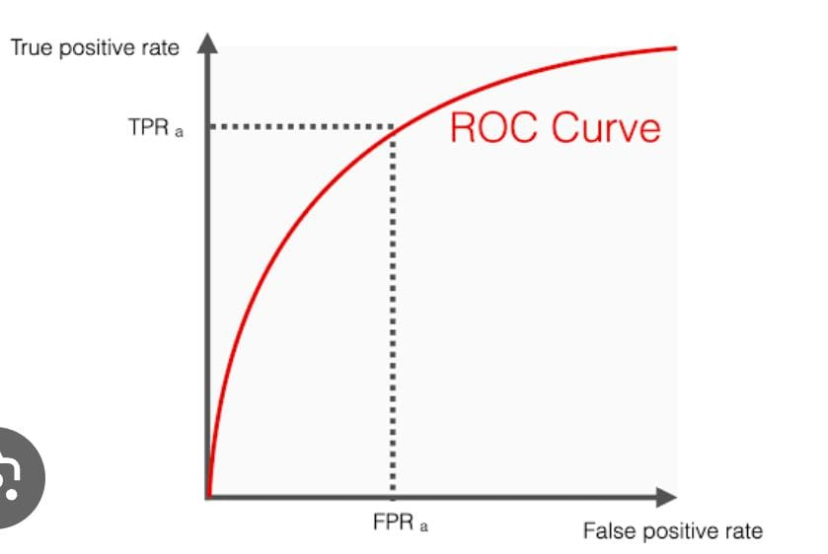

The Receiver Operating Characteristic (ROC) curve is a graphical representation of the performance of a binary classifier system across various threshold settings. It plots the True Positive Rate (TPR) against the False Positive Rate (FPR) at different threshold values.

True Positive Rate (TPR): Also known as sensitivity or recall, it measures the proportion of actual positive cases that are correctly identified by the classifier.

False Positive Rate (FPR): It measures the proportion of actual negative cases that are incorrectly classified as positive.

By varying the threshold at which the classifier decides to classify instances as positive or negative, the ROC curve shows how the trade-off between TPR and FPR changes. A good classifier will have a curve that is closer to the top-left corner of the plot, indicating high TPR and low FPR across different threshold settings.

The area under the ROC curve (AUC) is a commonly used metric to quantify the overall performance of the classifier. A higher AUC value indicates better discrimination ability of the classifier across all possible threshold settings.

In summary, the ROC curve provides a comprehensive view of a binary classifier's performance, illustrating its ability to distinguish between positive and negative instances across various decision thresholds.

Submitted by.

K. Lavanya

20AJ1A0462

(Amrita Sai institute of

Science and technology)